在虚拟机上运行Hello China

Hello China V1.5是基于传统的1.44M软盘（floppy）进行启动的。这样在开发或调试的时候十分不方便，每次都要写入软盘，并重新启动计算机。一个简便的方法是，采用虚拟机软件来模拟物理计算机，Hello China运行在虚拟机上。比如，在开发或调试用的计算机（称为宿主机）上安装虚拟机软件，并采用宿主机的物理软驱来作为虚拟机的启动设备。每次开发完毕，需要调试的时候，首先从宿主机上把编译后的Hello China影像写入软盘，并重新启动虚拟机。
这样可大大降低物理计算机的重启次数，使得调试过程变得方便。但随着硬件的不断更新换代，在新的计算机系统上，软盘驱动器已不是必配设备。这样就给Hello China的开发和调试带来了非常大的麻烦。为解决这个问题，作为过渡解决方案，我们采用虚拟软驱加虚拟机的方式来实现Hello China的引导问题。随着Hello China的深入开发，在后续版本中，Hello China会支持硬盘、光驱（CD/DVD等）等设备的启动。
虚拟软驱加虚拟机的解决方案十分简单，大致过程如下：
- 在宿主机上完成Hello China的开发或调试之后，会形成系统文件；
- 采用一个叫做VFMaker的程序，把系统文件写入一个虚拟软驱影像文件；
- 配置虚拟机软件，采用虚拟软驱影像文件来引导虚拟机。

这样就不需要有物理软驱了，只要在宿主机上安装一个虚拟机软件，就很容易且快捷的实现Hello China的开发和调试。目前流行的虚拟机软件主要有Virtual PC和VMWare，其中Virtual PC由Microsoft公司提供，可免费下载使用，VMWare也有免费使用版。相对Virtual PC，VMWare的界面似乎更加漂亮和友好，功能更加强大一些。本文对Hello China在这两种流行的虚拟机软件上的使用方法，都做详细介绍。

VFMaker程序
VFMaker程序是一个基于C语言开发，在Visual C++ 6.0下编译的小工具。这个工具读取Hello China系统盘所需要的四个文件（bootsect.bin/realinit.bin/miniker.bin/master.bin），然后按照虚拟软驱影像文件的格式，写入一个虚拟软驱影像文件。缺省情况下，虚拟软驱影像文件的名字为VFLOPPY.VFD。当然，也可通过修改VFMaker的源代码，更改这个缺省值，或者直接在Windows文件管理器中把VFLOPPY.VFD修改为其它名字。
下面是VMMaker程序的源代码，在VC 6.0上编译通过：

//This program makes a virtual floppy image for Hello China,which is used to load Hello China in virtual PC environment.
//It reads the four binary images,bootsect.bin,realinit.bin,miniker.bin and master.bin,into memory,and then write to a file
//named vfloppy.vfd according to specific format.
//
#include <stdio.h>
#include <stdlib.h>
#include <windows.h>
#include <string.h>

//Macros to specify the source and destination file name.
#define BOOTSECT_NAME TEXT("BOOTSECT.BIN")
#define REALINIT_NAME TEXT("REALINIT.BIN")
#define MINIKER_NAME TEXT("MINIKER.BIN")
#define MASTER_NAME TEXT("MASTER.BIN")
#define VFLOPPY_NAME TEXT("VFLOPPY.VFD")

//Constants to establish relationship between virtual floppy and physical floppy.
#define FD_HEAD_NUM 2 //2 headers for one floppy.
#define FD_TRACK_NUM 80 //80 tracks per header.
#define FD_SECTOR_NUM 18 //18 sectors per track.
#define FD_SECTOR_SIZE 512 //512 bytes per sector.

//The 1.4M floppy's size.
#define FD_SIZE (FD_HEAD_NUM * FD_TRACK_NUM * FD_SECTOR_NUM * FD_SECTOR_SIZE)
#define FD_TRACK_SIZE (FD_SECTOR_NUM * FD_SECTOR_SIZE) //How many bytes in one track.

//This routine writes the source file to target file,which is the virtual floppy file.
static bool WriteVf(HANDLE hBootsect, //Handle of the bootsect file.
HANDLE hRealinit, //Handle of the realinit file.
HANDLE hMiniker, //Handle of the miniker file.
HANDLE hMaster, //Handle of the master file.
HANDLE hFloppy) //Handle of the virtual floppy file.
{
bool bResult = false;
int nBootsectStart = 0; //The bootsect resides in floppy's first sector,track 0 and header 0.
int nBootsectSize = FD_SECTOR_SIZE;
int nRealinitStart = 2 * FD_SECTOR_SIZE; //The realinit resides in floppy's third sector,track 0 and hd 0.
int nRealinitSize = 4096; //Realinit.bin's size is 4K.
int nMinikerStart = 10 * FD_SECTOR_SIZE; //Miniker resides in 11th sector,track 0 and header 0.
int nMinikerSize = 48 * 1024; //Miniker.bin's size is 48K.
int nMasterStart = (7 * FD_SECTOR_NUM + 12) * FD_SECTOR_SIZE; //Master resides in
//track 7,sector 13,and header 0.
int nMasterSize = 560 * 1024; //Master.bin's size is 560K.
char* pBuffer = NULL;
char* p2Buffer = NULL;
char* pBuffPtr = NULL;
char* p2BuffPtr = NULL;
unsigned long ulRead = 0;
unsigned long ulToRead = 0;
int i;

//Check the parameters.
if((INVALID_HANDLE_VALUE == hBootsect) ||
(INVALID_HANDLE_VALUE == hRealinit) ||
(INVALID_HANDLE_VALUE == hMiniker) ||
(INVALID_HANDLE_VALUE == hMaster) ||
(INVALID_HANDLE_VALUE == hFloppy))
{
printf(TEXT("Invalid parameter(s) encounted.\r\n"));
goto __TERMINAL;
}
//Allocate temporary buffer.
p2Buffer = (char*)malloc(FD_SIZE); //In Windows system,should successful.But if you like,you can allocate a small
//buffer improve the success probality,and use a little more complicated algorithm
//to implemente this program.
if(NULL == p2Buffer)
{
printf(TEXT("Can not allocate enough memory.\r\n"));
goto __TERMINAL;
}
pBuffer = (char*)malloc(FD_SIZE); //In Windows system,should successful.:-)
if(NULL == pBuffer)
{
printf(TEXT("Can not allocate enough memory.\r\n"));
goto __TERMINAL;
}
memset(p2Buffer,0,FD_SIZE); //Clear content of the buffer.

//Now,read bootsect.bin into buffer.
pBuffPtr = pBuffer + nBootsectStart;
ulToRead = nBootsectSize;
if(!ReadFile(hBootsect,
pBuffPtr,
ulToRead,
&ulRead,
NULL)) //Can not read.
{
printf(TEXT("Can not read bootsect.bin.\r\n"));
goto __TERMINAL;
}
if(ulToRead != ulRead) //File's size may incorrect.
{
printf(TEXT("bootsect.bin size may incorrect.\r\n"));
goto __TERMINAL;
}

//Now,read realinit.bin into buffer.
pBuffPtr = pBuffer + nRealinitStart;
ulToRead = nRealinitSize;
if(!ReadFile(hRealinit,
pBuffPtr,
ulToRead,
&ulRead,
NULL))
{
printf(TEXT("Can not read realinit.bin.\r\n"));
goto __TERMINAL;
}
if(ulToRead != ulRead) //File's size may incorrect.
{
printf(TEXT("realinit.bin size may incorrect.\r\n"));
goto __TERMINAL;
}

//Now,read miniker.bin into buffer.
pBuffPtr = pBuffer + nMinikerStart;
ulToRead = nMinikerSize;
if(!ReadFile(hMiniker,
pBuffPtr,
ulToRead,
&ulRead,
NULL))
{
printf(TEXT("Can not read miniker.bin.\r\n"));
goto __TERMINAL;
}
if(ulToRead != ulRead) //File's size may incorrect.
{
printf(TEXT("miniker.bin's size may incorrect.\r\n"));
goto __TERMINAL;
}

//Now,read master.bin into buffer.
pBuffPtr = pBuffer + nMasterStart;
ulToRead = nMasterSize;
if(!ReadFile(hMaster,
pBuffPtr,
ulToRead,
&ulRead,
NULL))
{
printf(TEXT("Can not read from master.bin.\r\n"));
goto __TERMINAL;
}
//Because the master.bin's size may change,so no need to judge it's actually size.
//But in any case,master.bin's size must larger or equal to 64K,so we ensure it.
if(ulRead < 64 * 1024)
{
printf(TEXT("master.bin size may incorrect.\r\n"));
goto __TERMINAL;
}

//I made a mistake originally,assumed the mapping relationship between physical floppy and virtual floppy file
//is first track,second track,...,then another header. After several failures,I checked the documents related
//to the mapping relationship,found that it is first header,first track,then second header,first track.
//So I adjust the track sequence in pBuffer to p2Buffer,to statisfy the correct mapping relationship.If you want
//to write a more flexible program to create a virtual floppy image,please mind this.
//Thank windows,we can allocate any size memory block,this lets my work simple,hehe.But you also can allocate
//a big block of memory in Hello China.:-)
p2BuffPtr = p2Buffer;
pBuffPtr = pBuffer;
for(i = 0;i < FD_TRACK_NUM * FD_HEAD_NUM;i ++)
{
memcpy(p2BuffPtr,pBuffPtr,FD_TRACK_SIZE);
pBuffPtr += FD_TRACK_SIZE;
if(FD_TRACK_NUM - 1 == i)
{
p2BuffPtr = p2Buffer + FD_TRACK_SIZE;
}
else
{
p2BuffPtr += FD_TRACK_SIZE * 2;
}
}

//Write it to virtual floppy file.
SetFilePointer(hFloppy,0,0,FILE_BEGIN); //Write from begin.
if(!WriteFile(hFloppy,
p2Buffer,
FD_SIZE,
&ulRead,
NULL))
{
printf(TEXT("Write to Vritual Floppy File failed.\r\n"));
printf(TEXT("Please ensure no other process is using the virtual floppy file.\r\n"));
goto __TERMINAL;
}
if(FD_SIZE != ulRead) //Can not write the whole buffer to file,may has not enough disk size.
{
printf(TEXT("The byte mount written to virtual floppy file may incorrect.\r\n"));
printf(TEXT("Please check the physical storage where the virtual floppy file residing has enough space.\r\n"));
goto __TERMINAL;
}
SetEndOfFile(hFloppy);
//If reach here,the whole operation is successfully.
bResult = true;

__TERMINAL:
if(pBuffer)
{
free(pBuffer);
}
if(p2Buffer)
{
free(p2Buffer);
}
return bResult;
}

//Main entry.
void main()
{
HANDLE hBootsect = INVALID_HANDLE_VALUE;
HANDLE hRealinit = INVALID_HANDLE_VALUE;
HANDLE hMiniker = INVALID_HANDLE_VALUE;
HANDLE hMaster = INVALID_HANDLE_VALUE;
HANDLE hFloppy = INVALID_HANDLE_VALUE;
bool bResult = false;

//Open all source files.
hBootsect = CreateFile(BOOTSECT_NAME,
GENERIC_READ,
FILE_SHARE_DELETE,
NULL,
OPEN_EXISTING,
0L,
NULL);
if(INVALID_HANDLE_VALUE == hBootsect)
{
goto __TERMINAL;
}

hRealinit = CreateFile(REALINIT_NAME,
GENERIC_READ,
FILE_SHARE_DELETE,
NULL,
OPEN_EXISTING,
0L,
NULL);
if(INVALID_HANDLE_VALUE == hRealinit)
{
goto __TERMINAL;
}

hMiniker = CreateFile(MINIKER_NAME,
GENERIC_READ,
FILE_SHARE_DELETE,
NULL,
OPEN_EXISTING,
0L,
NULL);
if(INVALID_HANDLE_VALUE == hMiniker)
{
goto __TERMINAL;
}

hMaster = CreateFile(MASTER_NAME,
GENERIC_READ,
FILE_SHARE_DELETE,
NULL,
OPEN_EXISTING,
0L,
NULL);
if(INVALID_HANDLE_VALUE == hMaster)
{
goto __TERMINAL;
}

hFloppy = CreateFile(VFLOPPY_NAME,
GENERIC_WRITE,
FILE_SHARE_DELETE,
NULL,
OPEN_ALWAYS,
0L,
NULL);
if(INVALID_HANDLE_VALUE == hFloppy)
{
goto __TERMINAL;
}

//Create virtual floppy file now.
printf(TEXT("Writing to virtual floppy now...\r\n"));
if(!WriteVf(hBootsect,
hRealinit,
hMiniker,
hMaster,
hFloppy))
{
goto __TERMINAL;
}

bResult = true; //Mark the successful flag.

__TERMINAL:
if(hBootsect != INVALID_HANDLE_VALUE)
{
CloseHandle(hBootsect);
}
if(hRealinit != INVALID_HANDLE_VALUE)
{
CloseHandle(hRealinit);
}
if(hMiniker != INVALID_HANDLE_VALUE)
{
CloseHandle(hMiniker);
}
if(hMaster != INVALID_HANDLE_VALUE)
{
CloseHandle(hMaster);
}
if(hFloppy != INVALID_HANDLE_VALUE)
{
CloseHandle(hFloppy);
}
if(!bResult)
{
printf(TEXT(" Create virtual floppy image file failed.\r\n"));
printf(TEXT(" Please ensure the following file are in current directory:\r\n"));
printf(TEXT(" bootsect.bin\r\n"));
printf(TEXT(" realinit.bin\r\n"));
printf(TEXT(" master.bin\r\n"));
printf(TEXT(" miniker.bin\r\n"));
printf(TEXT(" And make sure the virtual floppy image file is not used by other process.\r\n"));
}
else
{
printf("Create virtual floppy image file (vfloppy.vfd) successfully!\r\n");
}
}

编译后生成VFMaker.EXE文件，在使用的时候，把这个文件跟Hello China引导所需要的四个二进制文件，拷贝到同一个目录下，然后直接执行VFMaker，即可生成目标文件。下面是一个实际的抓屏结果：

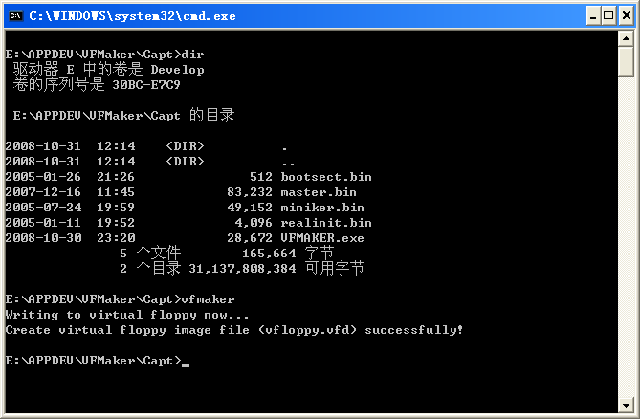

若一切正常，则该程序会提示创建虚拟软驱影像文件成功。这时候可看到当前目录下，存在一个vfloppy.vfd文件：

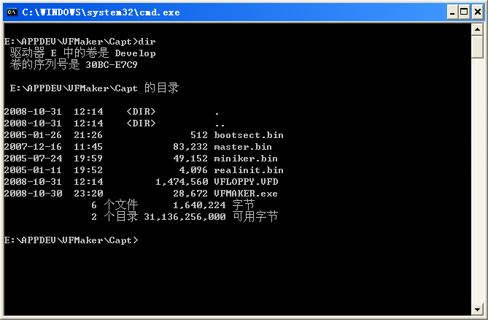

若因为某种原因，导致创建VFloppy.VFD失败，则该程序也会给出提示。一般情况下，VFMaker找不到四个二进制文件中的任何一个，或者磁盘空间不够，无法创建虚拟软驱影像（1.44M），则会执行失败。如下：

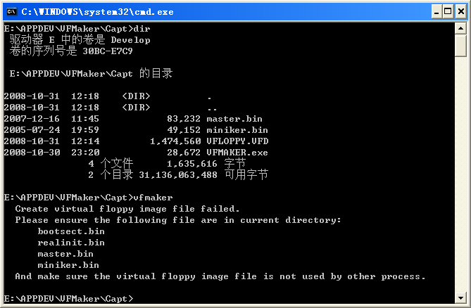

上述抓屏现实，由于少了bootsect.bin和realinit.bin两个文件，导致VFMaker执行失败。

虚拟软驱影像文件在Virtual PC上的使用
虚拟软驱影像文件创建之后，在Virtual PC上的使用就非常简单了。启动Virtual PC，并创建一个虚拟机，然后启动该虚拟机。
开始的时候，虚拟机会尝试从网络启动，这个时候可按CTRL + C终止。若找不到启动设备，虚拟机会停止启动，并提示缺少可引导设备。这时候，把虚拟软驱影像文件，用鼠标拖拽到虚拟机下面的软驱图标上，然后按任意键，就可启动了。
下面是一个Hello China V1.5在虚拟机上的运行情况截屏：

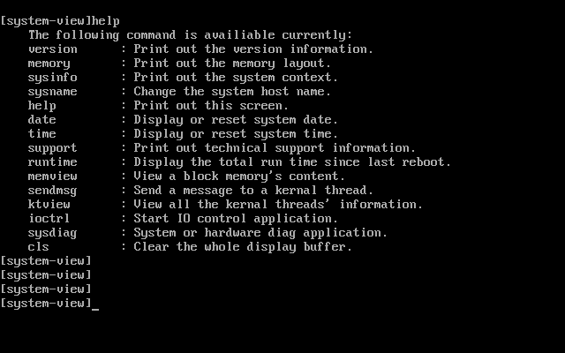

虚拟软驱影像文件在VMWare上的使用

在VMWare上的使用也非常简便，启动VMWare，并创建一个虚拟机。在创建虚拟机向导的最后一步，选择“Customize Hardware…”，增加一个虚拟软驱。缺省情况下，WMWare不会为虚拟机创建虚拟软驱。如下图：

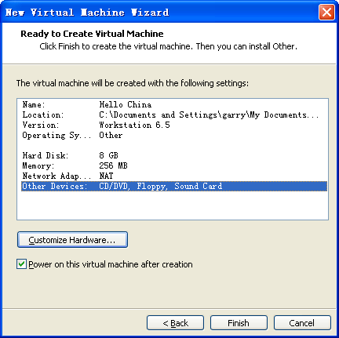

这时候会出现定制硬件对话框，Floppy，并选择“Use floppy image file”，给出虚拟软驱影像文件的具体位置，如下图。需要注意的是，一定要选择“Connect at power on”选项，否则虚拟机不会从虚拟软驱引导：

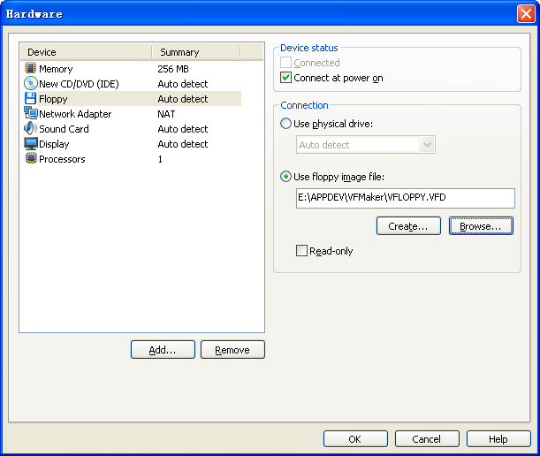

完成后选择OK，就可创建一个带虚拟软驱的虚拟机了。
创建之后，若一切正常，则虚拟机会正常引导Hello China，下面是一个引导成功后的屏幕截图：

